Art to Remember
This booklet is meant to guide your art to symbolize
REMEMBRANCE and PEACE...
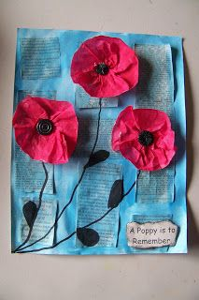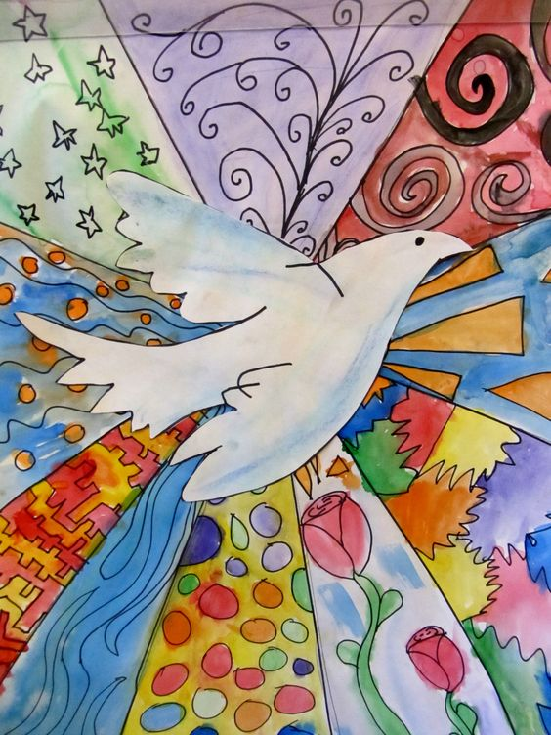
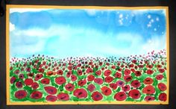

INTRODUCTION
Every day Canadian Armed Forces members put their lives at risk, often leaving their families and homes behind to courageously defend our country's values and contribute to international peace and security.
They have played many important roles both at home and around the world for many years. Whether protecting our frontiers, working with our allies, providing humanitarian assistance, helping restore peace in troubled countries or fighting those who would deny freedom to others, the men and women of the Canadian Armed Forces have stood tall. - http://www.veterans.gc.ca

ASSIGNMENT
Create a piece (or more) of artwork as a symbol of Remembrance and/or Peace that will address the outcomes below...

CURRICULUM OUTCOMES
Select and apply elements of art and principles of design to achieve composition
Engage in critical reflective thinking and planning as part of the decision-making and problem-solving process. (Why did you make the choices you made in the subject matter and art media?)
Use visual symbols to create meaning in your artwork
Understand and incorporate LAYERING and FOREGROUND, MIDDLEGROUND, and BACKGROUND into your artwork and or planning process

MEDIA (personal choice)
- Oil Pastels  - Chalk Pastels  - Watercolour Paints  - Pencil/graphite | - Coloured Pencil  - Markers  - Collage materials  - *you are encouraged to use more than 1 choice of art media*
*Because this is choice-based, clean-up will be more independent for this assignment and so be sure to return all art materials during clean-up time*

PROCEDURE
- Use some of the examples from the Art to Remember assignment package and draw 3-5 thumbnail sketches to generate ideas in your sketchbook (include a title on this page)
- Decide on the scale of your artwork and layout. Will you have your page in landscape or portrait format or will you choose to have a square composition?
- On your ‘good copy’ paper lightly draw in pencil, and then apply your chosen art media. Include your name in pencil on the bottom right corner.
- Use the rubric below to guide your art making and art project reflection process

Assessment Rubric
Outcomes | Marking Scale | Comments
Select and apply elements of art and principles of design to achieve composition | /4
Engage in critical reflective thinking and planning as part of the decision-making and problem-solving process (self-assessment and teacher observation) | /4  /4
Use visual symbols to create meaning in your artwork | /4
Understand and incorporate FOREGROUND, MIDDLEGROUND, and BACKGROUND into your artwork and or planning process | /4
1 - Does not meet required outcome
2 - Approaching outcome
3 - Meets outcome
4 - Meets and exceeds outcome
*BONUS* Create a Poppy Pinwheel for Peace...
