VISUAL ARTS 9

Night of the Arts Collaborative Projects

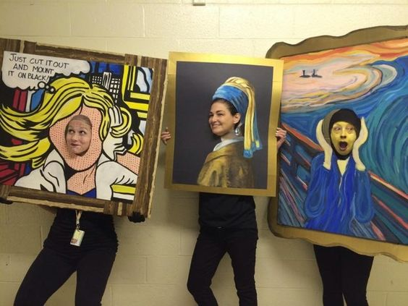

Introduction
Night of the Arts at NGRH is an exciting event that highlights the accomplishments of students in Music, Drama and Visual Arts. This year it takes place on December 6th at 6:30pm.
This assignment has multiple components and aims to allow you some collaboration with other students in the class. (GCO 1.2, 2.3, 5.2)
Use THE DESIGN PROCESS outlined on the following pages to help guide your process.

Problem: Night of the Arts is only a few weeks away and we need to make the following: Interactive Art, Informative Posters and Invitations.
#1 Design and create a poster for Night of the Arts
#2 Design and create invitations that can be printed for The Night of the Arts.
#3 Draw and colour Interactive Images
Research: What information do you need for your poster and invitations? What materials will you use?
POSTER:

INVITATION:

Ideas: rough sketches of at least 3 options
*What Elements of Art and Principles of Design will be featured in your design ideas?

Final Design: (include colour choices and scale)

